LPC (hold) | CPC (hold) | BLOC (hold) | NDP (hold) | GREEN (hold)
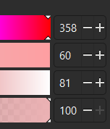 | 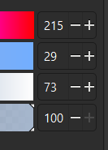 | 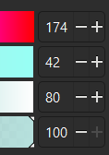 | 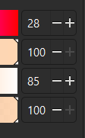 | 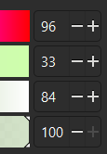
LPC (flip) | CPC (flip) | BLOC (flip) | NDP (flip) | GREEN (flip)
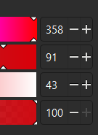 | 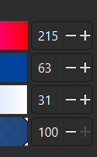 | N/A | N/A | N/A

The following seats changed allegiance from the 2021 redistributed results.
Conservative to Liberal  - Bay of Quinte  - Calgary Confederation  - Carleton  - Cumberland—Colchester  - Kelowna  - Peterborough  - Sault Ste. Marie—Algoma  - South Shore—St. Margarets  - South Surrey—White Rock  - Toronto—St. Paul's  - Winnipeg West  Liberal to Conservative  - Aurora—Oak Ridges—Richmond Hill  - Brampton West  - Calgary McKnight  - Cambridge  - Hamilton East—Stoney Creek  - Kitchener South—Hespeler  - Long Range Mountains  - Markham—Unionville  - Newmarket—Aurora  - Niagara South  - Richmond Centre—Marpole  - Richmond Hill South  - Sudbury East—Manitoulin—Nickel Belt  - Terra Nova—The Peninsulas  - Vaughan—Woodbridge  - Windsor—Tecumseh—Lakeshore  - York Centre | NDP to Liberal  - Burnaby Central  - Churchill—Keewatinook Aski  - Esquimalt—Saanich—Sooke  - Hamilton Centre  - New Westminster—Burnaby—Maillardville  - Port Moody—Coquitlam  - Victoria  NDP to Conservative  - Cowichan—Malahat—Langford  - Edmonton Griesbach  - Elmwood—Transcona  - Kapuskasing—Timmins—Mushkegowuk  - London—Fanshawe  - Nanaimo—Ladysmith  - North Island—Powell River  - Similkameen—South Okanagan—West Kootenay  - Skeena—Bulkley Valley  - Windsor West  Bloc Québécois to Liberal  - Abitibi—Baie-James—Nunavik—Eeyou  - Beauport—Limoilou  - Châteauguay—Les Jardins-de-Napierville  - La Prairie—Atateken  - LaSalle—Émard—Verdun  - Les Pays-d'en-Haut  - Longueuil—Saint-Hubert  - Mont-Saint-Bruno—L'Acadie  - Rivière-des-Mille-Îles  - Terrebonne  - Thérèse-De Blainville  - Trois-Rivières  Bloc Québécois to Conservative  - Montmorency—Charlevoix  Green to Conservative  - Kitchener Centre

